

**Course Information**

Course Title: Digital Image Processing

Section: 1

Course Instructor: Dr. Ahmed Wasif Reza

Associate Professor

Department of Computer Science & Engineering

**Lab-01**

**Student’s Information**

**Name:** Mujahidul Islam

**ID:** 2019-2-60-072

**Department:** Computer Science & Engineering

**Date of Submission: 20 October 2022**

**Ques 1**

a) Read and show the image

Code: 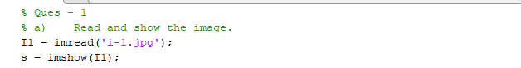

Output:

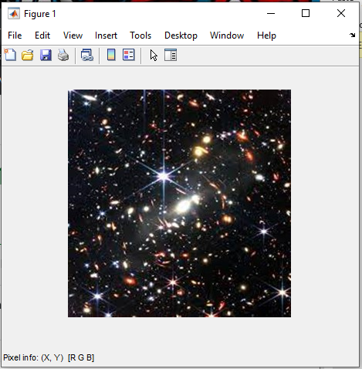

b) Show the matrix form of the image.

Code:



Output:

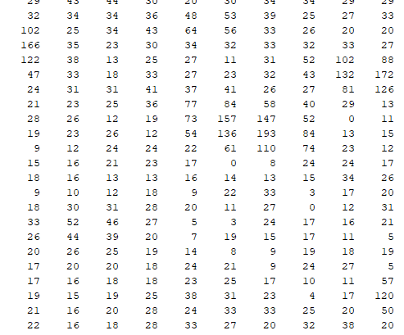

c) Show the pixel information by hovering the cursor on the image.

Code:



Output:

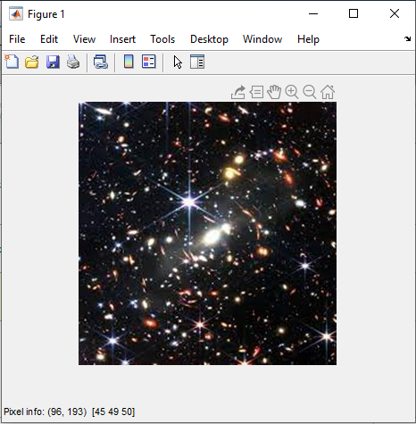

d) Find the value of the pixel (10, 78).

Code:

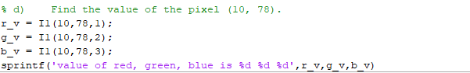

Output:

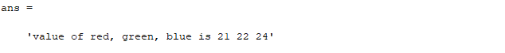

e) Show the size of the image.

Code:



Output:



f) Show the all the information of the image.

Code:



Output:

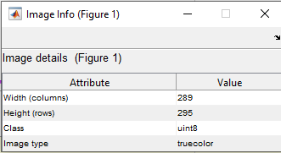

Fig: image information

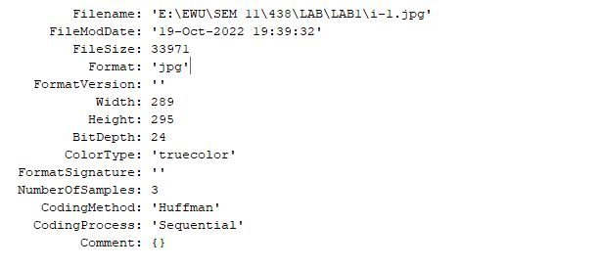

Fig: image file information

**Ques 2**

a) Read and show all three types of images (RGB, Grayscale, and Indexed)

Code:

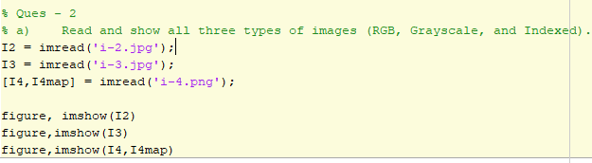

Output:

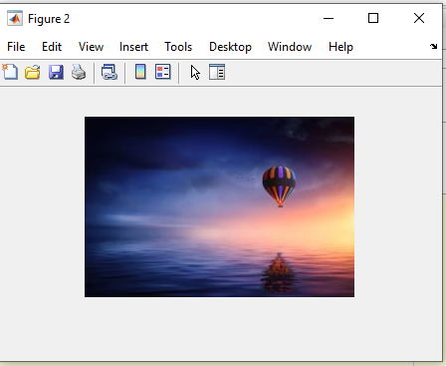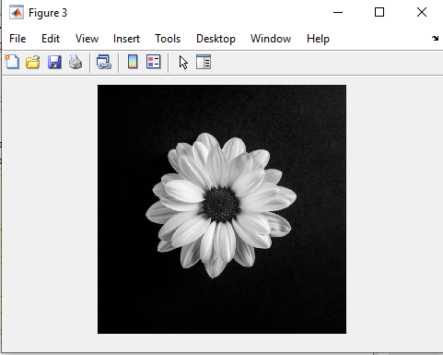

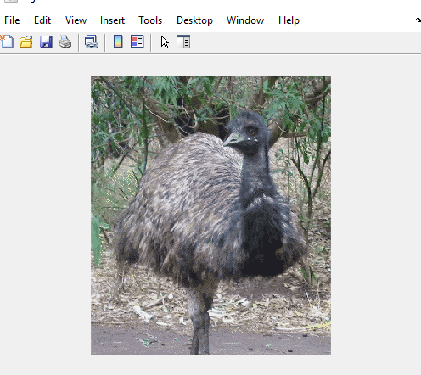

b) Turn the RGB image to Grayscale image.

Code:



Output:

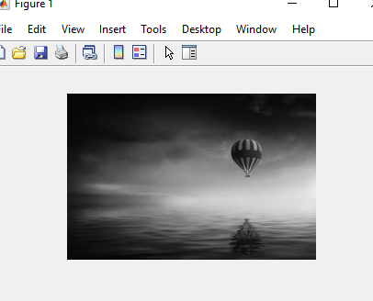

Fig: RGB image Fig: Grayscale image

c)Turn the Indexed image to Grayscale image.

Code:



Output:

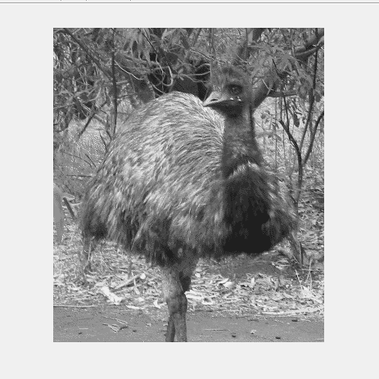

Fig: Indexed image Fig: Grayscale image

d) Turn the Indexed image to RGB image.

Code:



Output:

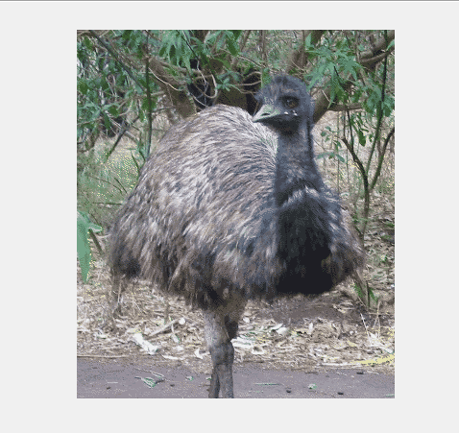

Fig: Indexed image Fig: RGB image

e) Convert the Grayscale image to a Binary image.

Code:



Output:

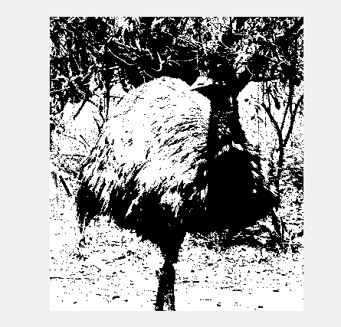

Fig: Grayscale image Fig: Binary image

f) Show the inverted form of that Binary image.

Code:



Output:

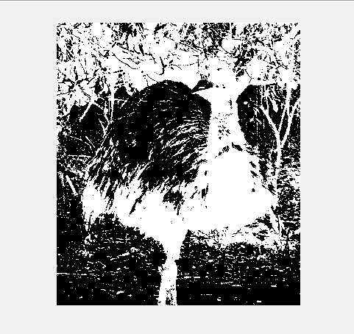

Fig: Binary image Fig: Inverted binary image

g) Show the histogram of the Grayscale image.

Code:



Output:

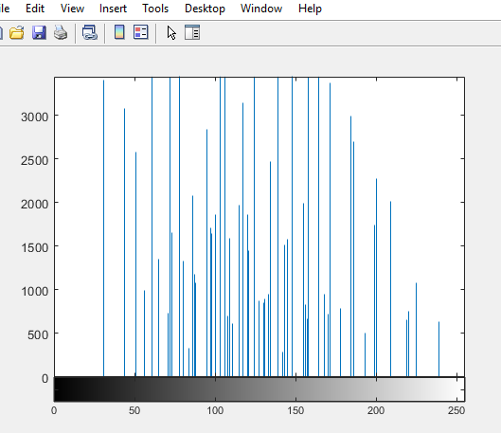

h) Invert the RGB image.

Code:



Output:

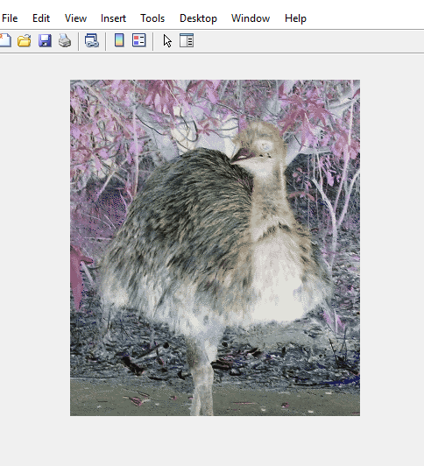

Fig: RGB image Fig: Inverter RGB image

i) Blur the RGB image.

Code:

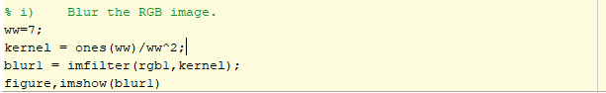

Output:

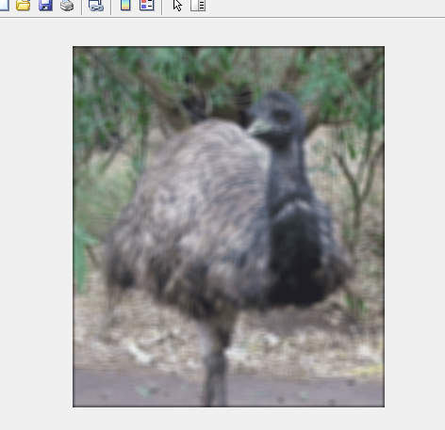

Fig: RGB image Fig: Blur image

**Ques 3**

Create a complete black image of size 256 X 256.

Code:



Output:



**Ques 4**

Create a complete white image of size 256 X 256.

Code:

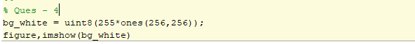

Output:



**Ques 5**

Adjust the contrast of the following image.

Code:

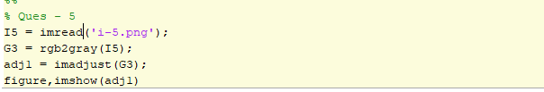

Output:

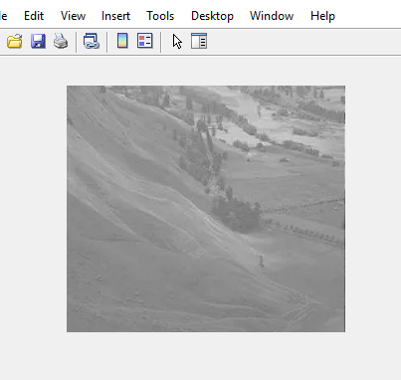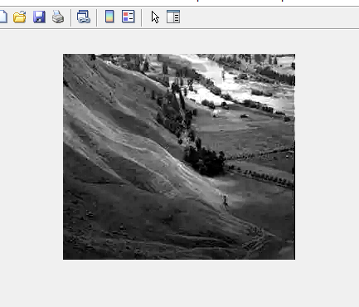

Fig: Image Fig: Contrast adjusted image

**Ques 6**

Brighten the following image

Code:

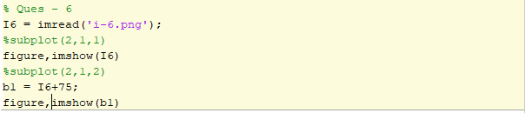

Output:

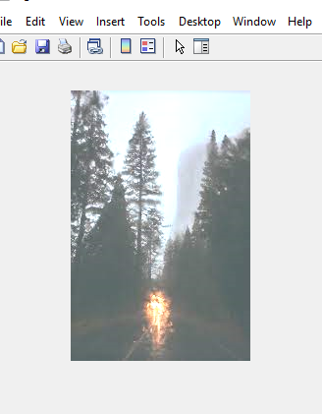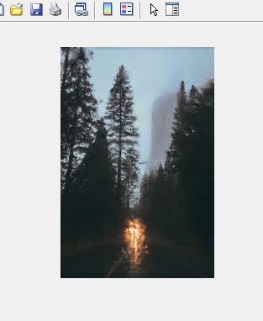

Fig: Low brighten image Fig: High brighten image

**Ques 7**

Quantize the Grayscale image by 8 levels.

Code:

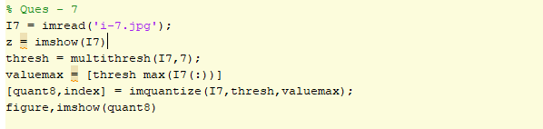

Output:

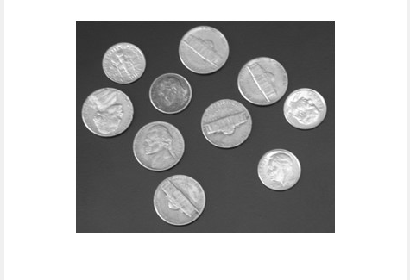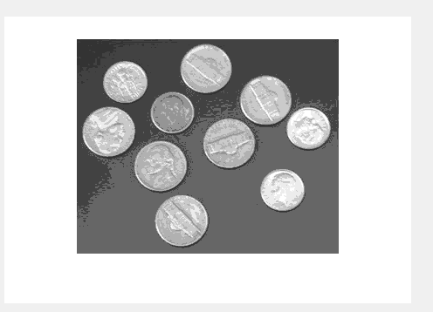

Fig: Gray scale image 256 level Fig: Quantized by level 8 image